## ***The Elder Scrolls***

*Unofficial Roleplaying Game*

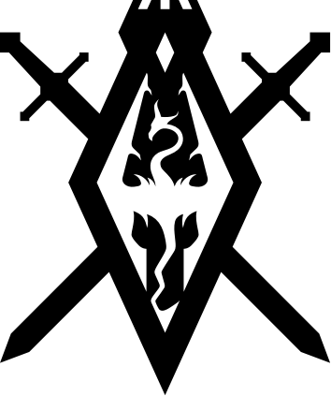

Core Rulebook

*By TutorialTuna*